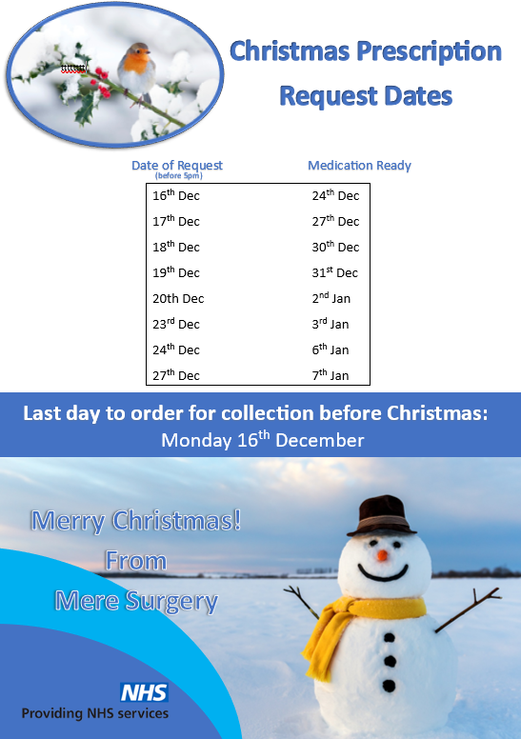

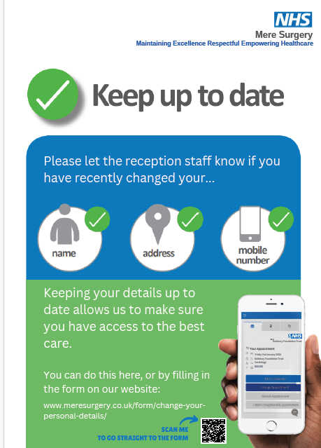

DISPENSARY & RECEPTION OPENING HOURS
Monday 0830 – 1700
Tuesday 0830 – 1700
Wednesday 0830 – 1700 We will be closed Christmas Day 25th December
Thursday 0830 -1700 We will be closed on boxing day 26th December
Friday 0830 – 1700 We will be closed on New years Day 1st January

CONTACT US
01747 860001
WEBSITE
www.meresurgery.co.uk

Please note you may be offered appointments outside of these times.

Our NHS is asking the public to use 111 and not A&E over Christmas except for 'life-threatening emergencies' “It's important people only attend A&E for emergency care.” The public is being urged to use NHS 111 instead of going to A&E over the festive period unless it's a serious injury or a life-threatening emergency

We are no longer providing any Covid Vaccination here but these are other ways you can book your appointment.

How to get the COVID-19 vaccine

If you're eligible for the winter COVID-19 vaccine, you can:

book a COVID-19 vaccination appointment online https://www.nhs.uk/nhs-services/covid-19-services/covid-19-vaccination-services/book-covid-19-vaccination or in the NHS App – https://www.nhs.uk/nhs-app/ you need to book your vaccination before 20 December 2024

go to a walk-in COVID-19 vaccination site. This is available until 31st January 2025 Find a walk-in COVID-19 vaccination site - NHS

You can call 119 free of charge to book over the phone if you cannot book online. It's open Monday to Friday, 8am to 8pm.

Some people may be able to get vaccinated through a local service, such as a community pharmacy or a care home if they live in a care home.

You do not need to wait for an invitation before booking an appointment.

Support Services

Men's Friendship Group, Warminster
Description
We Are Men (WAM) is a weekly friendship group for men to come together for support and laughter. The group meet at the Warminster Football Clubhouse.
Service Details
Locations:
Warminster Town Football Club, Weymouth Street, Warminster, BA12 9NS
Organisation:
We Are Men (WAM)
Service Type:
Social and Support
Time and date information
When is it on:
Monday 7pm-9pm
Service Focus
Pricing:
Free


Carer Cafe - Mere

Description
Carers Cafes are a great way to connect with other carers to share experiences and receive or offer support.
Service Details
Locations:
Angel Tea Rooms, Angel Lane, Mere, BA12 6DH
Organisation:
Carer Support Wiltshire
Service Type:
Services for Carers
Website:
Carer Cafe - Mere | Your care Your support Wiltshire
When is it on:
Third Monday of each month 2.30pm-4pm
Service Focus

What is a Pharmacy Technician

Sophie works as a Pharmacy technician here at Mere Surgery.

Pharmacy Technicians play an important role, complimenting clinical pharmacists, community pharmacists and other members of the PCN multi-disciplinary team.

Sophie’s main responsibilities are to support the GP’s with ensuring patients are using their medications effectively, reconciling medication and ensuring medication is synchronised for patients moving between care settings such as hospital to care home or back to patient’s own home.

Sophie helps the practice to maximise safe, cost-effective, prescribing to improve the quality of patient care. Sophie can help patients get the best from their medicines, use existing protocols to maximise cost-effective preparations, improve repeat prescribing processes (including use of electronic repeat dispensing and online ordering), minimising clinical risk and reducing avoidable wasted medicines.

Sophie can research and help patients with any medication query, this can include issuing alternative medication that is not available or out of stock, inhaler techniques, researching and advising side effects of medication or any quantity discrepancy on patients repeat slips.
Would you like to join our Patient Participation Group or PPG?

A Patient Participation Group (PPG) is a group of people who are patients of the surgery and want to help it work as well as it can for patients, doctors and staff. The NHS requires every practice to have a PPG.

Why should I join?

You have been to the surgery as a patient, parent, carer or friend. Your experiences matter and you can bring different ideas to the surgery to help us treat patients better or to improve what we do in some way. You will also gain a better understanding of the NHS, and gather feedback from other patients.

Please speak to reception if you would like to join.



Green Impact is a multi award-winning sustainability learning and awards programme, designed to embed environmentally and socially sustainable practices within organisations.

At Mere Surgery we have been making efforts to reduce our carbon footprint and practice more sustainably. Over the years we have made improvements to our infrastructure that includes solar energy, air source heat for the central heating and converting all the lights to LEDs.

Practicing more sustainably always involves keeping patients well, practicing preventative medicine rather treatment after diseases and conditions have developed.

Some prescribing has also altered, for example converting the right patients from aerosol inhalers to dry powder inhalers.

We are also keen to recycle more, currently you can recycle your inhalers, glasses, hearing aid batteries all at the surgery.

For these measures we have been awarded a Bronze, Green Impact Award.

Wishing you all a happy and healthy Christmas and new year.



A big thank you for your gifts and cards, these are very much appreciated and shared with all the staff.

