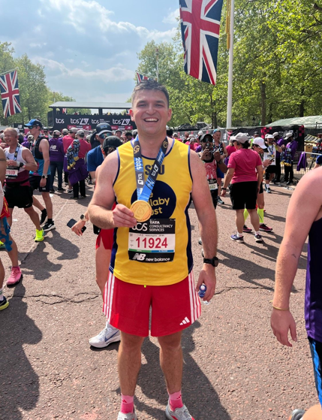

Dr Gallagher successfully completed the London Marathon on Sunday 27th April. In total he raised an amazing £2929.

All proceeds raised are for The Lullaby Trust Charity which is a charity that saves babies' lives and supports bereaved families. Around 3 babies a week still die from sudden infant death syndrome (SIDS), The Lullaby Trust is committed to bringing that number down to zero.

Thank you to all patients who very kindly donated.
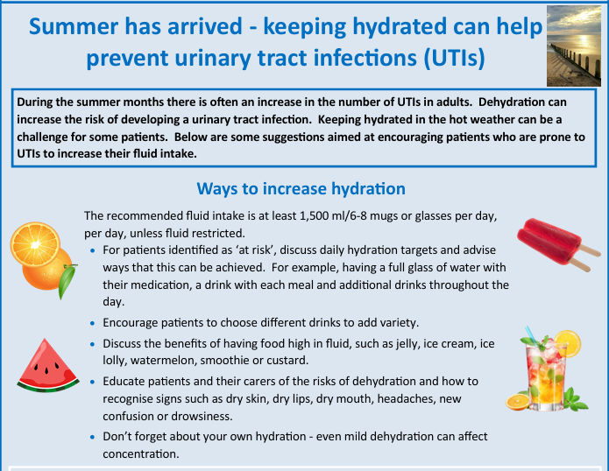

FLU/COVID CLINICS

We will be planning our Flu and Covid vaccination clinics shortly and will endeavour to keep you updated with the dates. Please do not contact the surgery about this as invites will be sent out nearer the time for all eligible patients. It is important that all your contact details are up to date, so you receive these invites. Keep an eye on our website for further information.

MEET JULIA OUR HEALTH AND WELLBEING COACH
My role as a Health & Wellbeing Coach is to work with and support our patients with physical and/or mental health conditions and those at risk of developing them. I draw on my training as a Specialist Public Health Nurse to encourage & motivate behaviour change to promote self-management and focus on improving health related lifestyles and outcomes.

The patients I see are variable (often with the season); some need support with weight management, diet and increasing activity levels. Others with long term conditions including type 2 diabetes, hypertension and high cholesterol. Whereas many others need support with stress, low mood, anxiety and bereavement. Every patient has a different life story and journey, which makes the job so interesting (especially for someone with an inquisitive disposition like me).

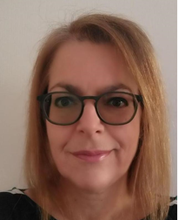



A "green recycle plan" for General Practices (GPs) focuses on reducing the environmental impact of healthcare services. This involves implementing strategies to minimise waste, conserve resources, and promote sustainable practices within the practice and among patients. Key areas include waste reduction, energy conservation, sustainable prescribing, and promoting active travel.

CONTACT INFORMATION

Is your contact information up to date? As we are trying to be greener, we prefer to send you messages or emails to save on paper and the impact on the environment.

Please let us have your email address and mobile telephone number – we will send you a link to verify these details are correct, ensuring your information remains confidential. If your contact details are not verified, we are unable to send you information this way.

We are very pleased to welcome Dr Emily Brockbank to Mere Surgery. She is a trainee GP and will be with us until February.

Congratulations to Dr Clem Stephenson and her husband on the birth of their son.
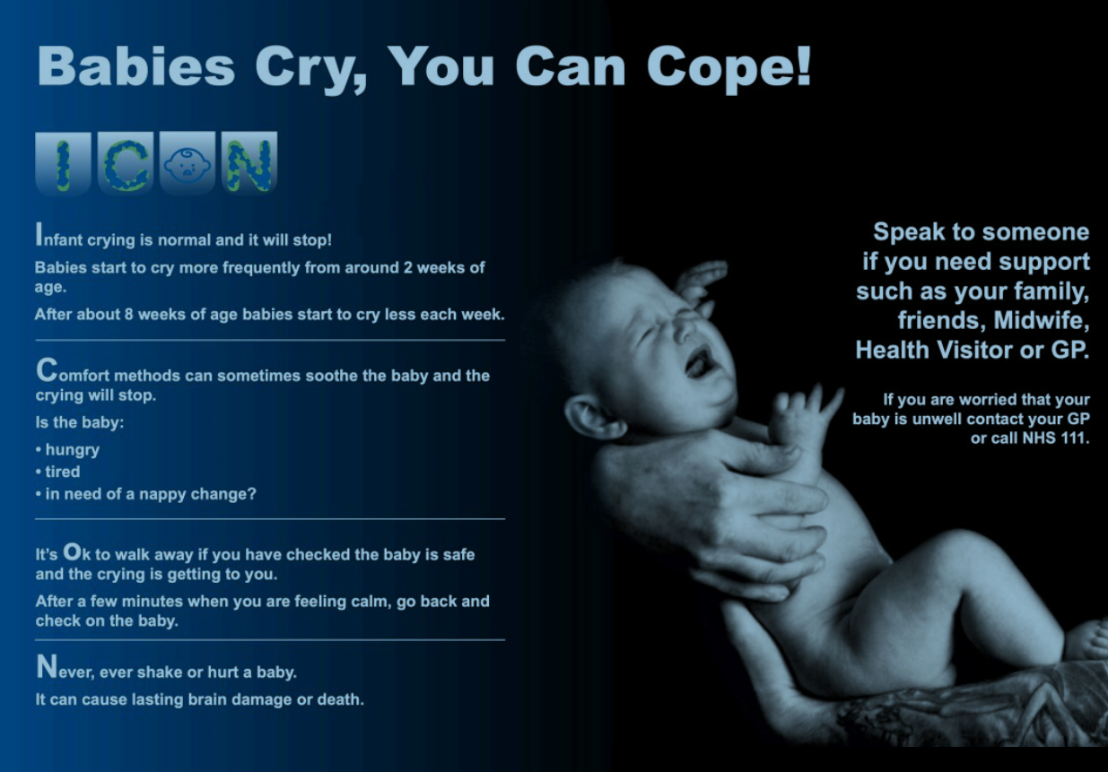
PPG FUNDRAISER

A huge “Thank you” to our patients and residents of Mere, who so generously contributed to the successful fund-raising events in aid of a replacement defibrillator for the surgery.

Our Patient Participation Group arranged two events, a Coffee Morning and a Garden Party and we would like to thank Mary and Nigel Wilson who kindly offered their garden for the event. These combined events raised £2006.25

Mere Social Club contributed £100 towards the fund raising and Bramley House held a Garden Party raising £292

All of these combined events raised a total of £2398.25.

The PPG would like to thank Mary, Nigel and Sam Wilson for all their help and support. Also, for the people of Mere, Zeals, Kilmington, Stourton and the Deverills who supported them so well.

We will update you once we receive the equipment but, in the meantime many thanks to you all.

FIRST CONTACT PHYSIO
We are pleased to confirm Jessica Church has started with us as our First Contact Physiotherapist, initially working on a Monday and Thursday.

From September she will work Monday all day and Wednesday/Thursday mornings.

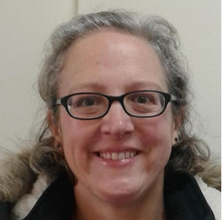

GET MERE MOVING
Thank you to all the volunteers who kindly gave up their time to come along to our Get Mere Moving morning on the 5^{th of} July. Much fun was had trying out Zumba and Bounce (much of this was done in the surgery garden until the rain came!)

Colin Fricker from Fitness by Design kindly opened his home gym for the morning and Mere Walking Group took people out for a short walk around Mere. The morning ended with a gentle chair yoga session.
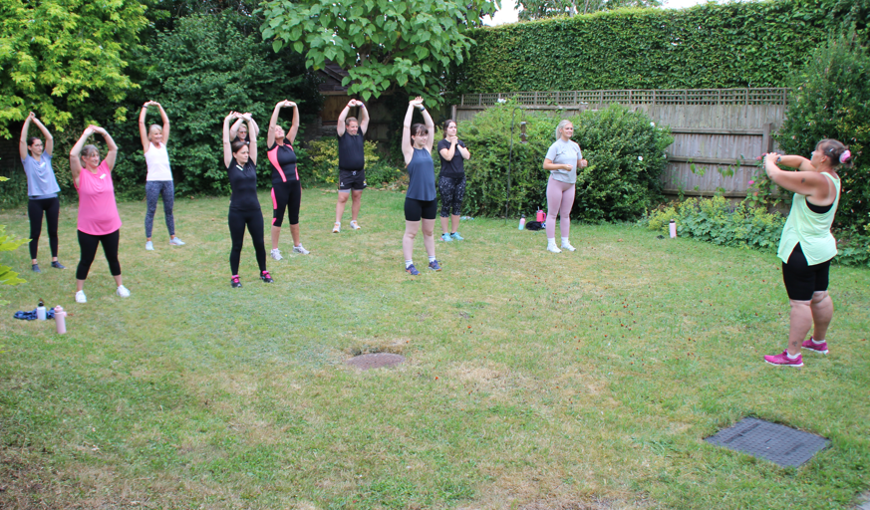

TELEPHONE UPDATE

We have been experiencing some intermittent technical issues with our telephone system over the past few weeks. This has been investigated and has now been resolved. Please accept our apologies if you have experienced any difficulties getting through to the surgery.

DISPENSARY & RECEPTION OPENING HOURS

Monday 0830 – 1700
Tuesday 0830 – 1700
Wednesday 0830 – 1700
Thursday 0830 -1700
Friday 0830 – 1700

CONTACT US on 01747 860001 or via our website www.meresurgery.co.uk

Please note you may be offered appointments outside of these times.

These are the results of the recent GP patient survey.
Thank you all for your input and support.

