Mere Surgery
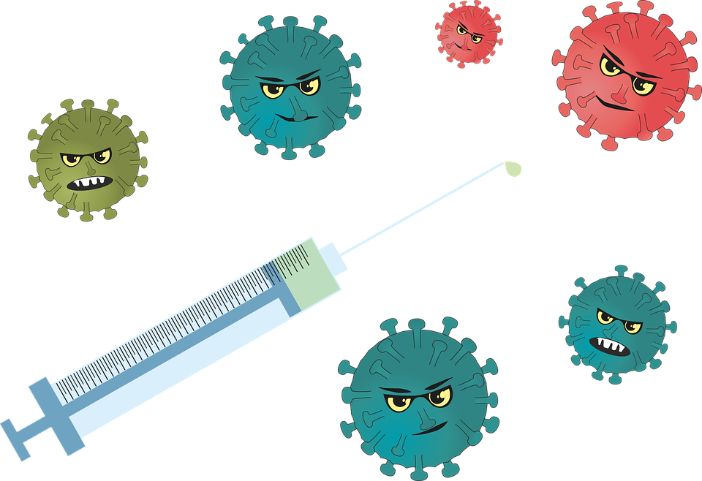
FLU and COVID CLINICS

Please find details of the Surgery’s vaccination programme below

WHEN AND WHERE WILL THE CLINICS BE HELD?

Saturday 11 October and Saturday 25 October at
Mere Surgery

WHO IS ENTITLED TO A FLU VACCINATION THIS YEAR?

- Anyone aged over 65
- Carers
- Pregnant women
- Any adult with following conditions:
COPD
Chronic heart disease
Chronic kidney or liver disease
Chronic neurological disease i.e. motor neurone
Parkinson’s
Learning disability
Diabetes
Weakened immune system due to chemotherapy or auto immune disorders
- BMI greater than 40.

WHO IS ENTITLED TO A COVID AUTUMN BOOSTER?

- Anyone aged 75 and over
- Any adult with a weakened immune system due to chemotherapy or auto immune disorders

HOW TO BOOK AN APPOINTMENT
Anyone with a mobile phone registered with the surgery to accept text messages will be sent a text message which will contain a unique link to book an appointment.

If you need to contact the surgery to make an appointment, please wait until you have been contacted with an invitation to book an appointment. Please DO NOT contact the surgery until you have been sent an invitation. We apologise if you received more than one message.

CHILDREN’S FLU CLINICS
Information regarding flu clinics will be available at a later date.

IF YOU DO NOT WISH TO HAVE EITHER A FLU VACCINATION OR COVID VACCINATION THIS YEAR, PLEASE LET THE SURGERY KNOW OR RESPOND VIA TEXT WHEN YOU RECEIVE THE INVITATION.

Please bear in mind we are reliant on the vaccinations arriving as planned, so please check our website for any updates.

Thank you

