Here she worked in musculoskeletal outpatients managing a caseload of GP and consultant referrals as well as teaching and supervising students and newly qualified physios. After having her children Jess worked part-time in the NHS musculoskeletal outpatients for several years before setting up a private practice.

Jess now works at Mere Surgery as a First Contact Physiotherapist giving telephone advice first on a range of conditions such as back pain, injuries and arthritis. She will also see you face to face as needed and can refer you for local physiotherapy or for an orthopaedic opinion as needed. Jess works closely with the doctors and other healthcare teams within the surgery to ensure you are properly assessed and signposted for the right advice and input for your condition.

MEET JESSICA CHURCH, FIRST CONTACT PHYSIOTHERAPIST

Mere Surgery is pleased to welcome Jess Church to the practice. She is a Chartered Physiotherapist who qualified in 1996 from Bath School of Physiotherapy (Bath University). Her first few years were spent in the NHS gaining experience in a broad range of settings such as orthopaedic wards, pain clinic, rheumatology, paediatrics and intensive care. She specialised in musculoskeletal physio after 4 years and spent 6 years as a senior then team leader in Bristol.
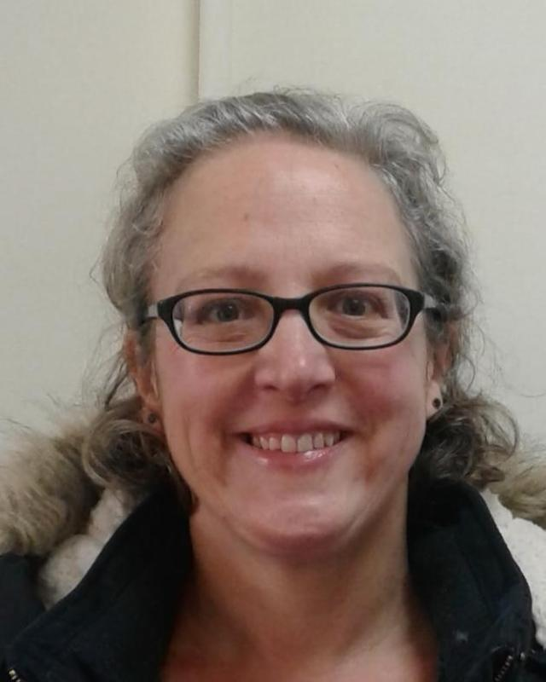
COVID AND FLU CLINICS

We have almost completed our flu and covid autumn vaccination programme. There remain some flu vaccinations still available until the end of January and these can be booked ad hoc if you are eligible.

Thank you for tolerating the slightly busier than planned Saturday clinics and supporting the surgery and the NHS by having them done at the surgery.
HOSPITAL REFERRALS

Been referred to the hospital? Several times a day we receive questions about when a clinic appointment might be expected at the hospital. Unfortunately, we do not have access to this information. If you know the hospital you have been referred to you can phone them direct to enquire how long you are likely to wait before receiving an appointment.

Because of often long hospital waiting times it is important to inform the surgery if your symptoms are rapidly deteriorating or changing.

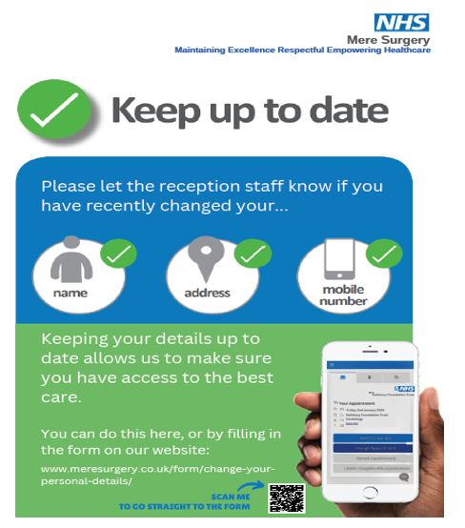

Please note if the surgery door is locked between the following times:

Monday to Friday – 0800 and 0830 hours
Monday to Friday – 1700 and 1830 hours

The Partners are still contactable via 111 for urgent medical issues.

If you have arranged a Face-to-Face appointment after 1700 hours with a GP please ring the doorbell and a GP will answer the door as soon as possible.

Please be patient as the GP may be speaking to another patient but please be assured they will answer the door as quickly as possible.

If you have a non-urgent request, please contact reception on the next working day. Reception is open from 0830 – 1700 hours Monday to Friday.

Many thanks for your co-operation.
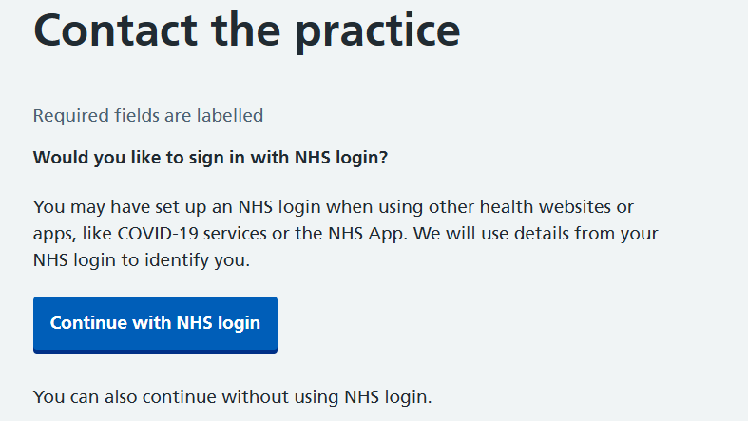
LOG IN WITH YOUR NHS APP WHEN USING OUR WEBSITE

When using our website, you can now complete forms by using your NHS log in details, if you have registered to use the NHS App. It does not apply if you are registered for Airmid or Systmonline.

Advantages are the form gets pre-populated with your details saving you time and reducing the risk of errors.

DIGITAL RESULTS FOR CERVICAL SCREENING

The NHS has recently started sending results from the NHS Cervical Screening Programme via the NHS App.

Those who have a negative test result will be notified of this by an NHS App message. It will also appear as an NHS App notification. If the NHS App message isn’t read within 72 hours, a letter will be sent as a failsafe.

Abnormal result letters will continue to be delivered by post for the time being.
Are you experiencing any of the following symptoms:

- Cough
- Cold
- Flu-like symptoms?

Please consider wearing a mask in the surgery if you are experiencing symptoms of a respiratory virus,

If you have any of the above, please inform reception staff on arrival.

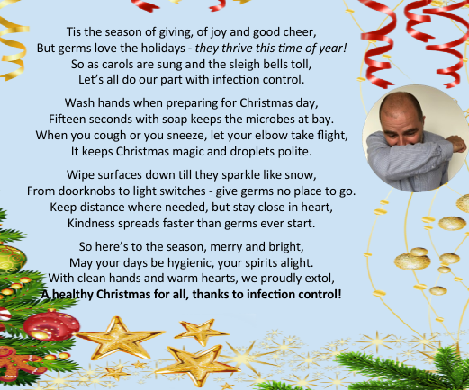
HOW TIMES HAVE CHANGED?


Thank you so much to Jean Booth who has created the display in the waiting
room of the past GPs of Mere stretching back to 1566.

As the demands on general practice over the years have changed, services
have not always developed for the better. Some of the recent pressures on
general practice are debated in an excellent book called “What is a doctor?” by a Somerset GP, Phil Whitaker. It probably best describes the pressures to change but what we hope to retain and strive for at Mere Surgery; most notably patient centred care and continuity of a trusted doctor/patient relationship.

CHILDRENS FLU CLINIC

The childhood flu vaccines in stock expire on 15th December 2025.

We are offering nasal flu vaccination for children under 18 at risk and all 2 & 3 year olds. The community nurses administer them for all school age children and will offer a catch up programme if they have been missed. If you wish to decline please let us know.

SHINGLES VACCINE

The shingles vaccine helps protect against shingles. It's available on the NHS for all adults turning 65, those aged 70 to 79 and those aged 18 and over with a severely weakened immune system.

Here is a link to the calculator to see if you are eligible:

UKHSA_12732_Shingles-Eligibility-Calculator-.xlsx

Or type into your browser ‘UKHSA 12732 Shingles’ and look for the
below:

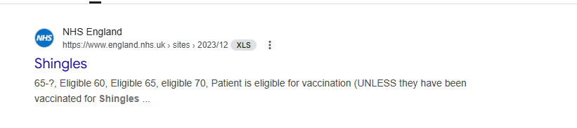

This will also take you to the eligibility calculator.

Shingrix is a non-live vaccine, with x2 dose 6 months apart

If you think you are eligible please contact reception to make an appointment.


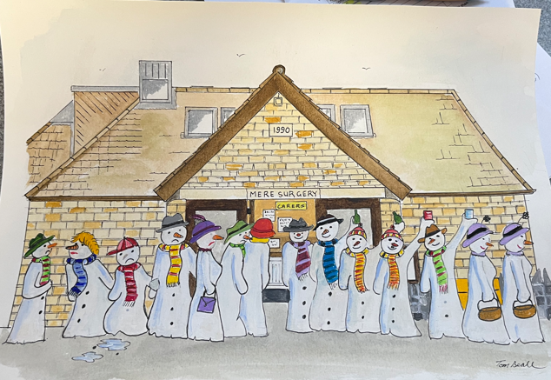

Thank you to Thomas Beall, a member of the local art group who kindly thought we might like the drawing (on left).

It is currently being framed and will be put on display along with other festive decorations.

