Mere Surgery
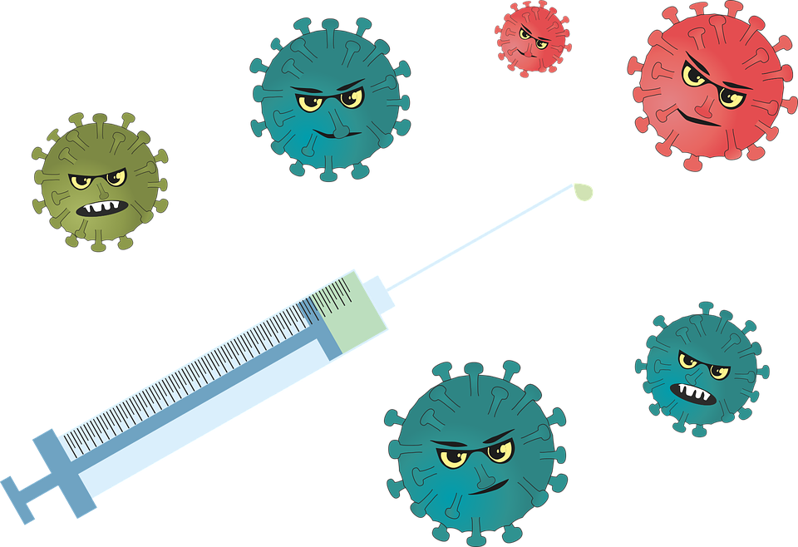
COVID CLINIC – SPRING BOOSTER

Please find details of the Surgery’s vaccination programme below

WHEN AND WHERE WILL THE CLINICS BE HELD?

Saturday 25 April at Mere Surgery between 8.30am – 1.00pm

WHO IS ENTITLED TO A COVID BOOSTER?

- Anyone aged 75 and over
- Any adult with a weakened immune system due to chemotherapy or auto immune disorders

HOW TO BOOK AN APPOINTMENT

Anyone with a mobile phone registered with the surgery to accept text messages will be sent a text message containing a unique link to book an appointment.

If you need to contact the surgery to make an appointment, please wait until you have been contacted with an invitation to book an appointment. Please DO NOT contact the surgery until you have been sent an invitation. We apologise if you receive more than one message.

IF YOU DO NOT WISH TO HAVE A COVID VACCINATION THIS YEAR, PLEASE LET THE SURGERY KNOW OR RESPOND VIA TEXT WHEN YOU RECEIVE THE INVITATION.

Please bear in mind we are reliant on the vaccinations arriving as planned, so please check our website for any updates.

Thank you

