Alternatively Mere Pharmacy are offering vaccinations.

WHO IS ENTITLED TO A COVID BOOSTER?

- Anyone aged 75 and over
- Any adult with a weakened immune system due to chemotherapy or auto immune disorders

Covid Clinic – Spring Booster

We are holding a Covid Clinic on Saturday 25 April at the surgery between 8.30am – 1.00pm.

This clinic is fully booked.

If you are eligible (please see below) you will be contacted by the NHS Booking Service to make an appointment or you can follow this link:

https://www.nhs.uk/nhs-services/vaccination-and-booking-services/book-covid-19-vaccination


ADHD & Autism Referrals

We are seeing an increasing amount of referrals for ADHD and/or Autism. You can be referred to a local NHS service but the waiting times for this are very long. There are a wide range of providers offering the same service under the NHS Right to Choose for both adults and children.

If you think you may have ADHD and/or Autism and are considering being referred for an assessment please take a look at the link below which lists all the different providers you could be referred to. Once you have decided which provider you would like to be referred to please contact reception to make a telephone appointment to discuss this. Please ensure you check that the provider you have chosen covers the area in which you live and be aware that they usually only offer online sessions not face to face consultations.

http://adhduk.co.uk/right-to-choose/right-to-choose-wait-times/

We do not make recommendations about which provider is the most suitable for you. You are responsible for doing your own research.

 What is an NHS Health Check?
The NHS Health Check is a free check-up of the health of your heart and blood vessels (cardiovascular health). It can tell you whether you're at higher risk of getting certain health problems. You will be invited by us to attend and during the check-up you'll discuss how to reduce your risk of these conditions. In the prevention of heart attacks and strokes, managing high blood pressures and cholesterol levels is important, however both these conditions need identifying.
Every 5 years from age 40 to 75 years you can have an NHS health check at the surgery with one of the nursing team that includes a blood pressure and cholesterol check. Targets for blood pressure are generally under 140/90 on a home monitor but targets for cholesterol are a little more complicated. In recommending ‘statin’ medications to treat cholesterol levels a risk score is generated using other statistics.
Our Pharmacist, Ruth, and Pharmacy Technician. Sophie, support the surgery with monitoring and instigating treatments to reduce heart attack and stroke risks and so you might receive a telephone call from them rather than a Doctor.
Lifestyle choices are as important to maintain health and if you would like support in weight management, exercise ideas, sleep, managing stress or anxiety then you are welcome to book an appointment with our Health and Wellbeing Coach, Julia.
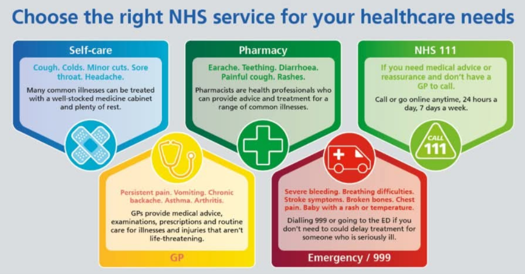
What is an FCP and how does it relate to physiotherapy?

First Contact Practitioners (FCPs) are advanced practitioners, (often physiotherapists but can also be paramedics) working within primary care with extensive expertise in the clinical assessment, diagnosis and management of musculoskeletal (MSK) conditions. (www.csp.org.uk)

FCPs can assess back and joint pains, injuries of muscles, ligaments or nerves. They can request x-rays and some may also be able to request blood tests and prescribe medication. They can refer into hospital departments such as orthopaedics and work closely with GPs to ensure they are safe practitioners.

An FCP appointment is an assessment and advice session but also may include a couple of sessions of physio where appropriate.

The NHS physiotherapy service locally (usually Warminster) is available for free physio and can help you recover from an injury or operation. This physio service has close links with the Orthopaedic Interface Service and can refer into orthopaedics if you need any extra investigations for your condition. This physio service can also refer you for hydrotherapy in Salisbury and has classes for some conditions such as back and knee classes.

Patient Participation Group

The Patients’ Participation Group (PPG) is formed of a group of patients from Mere surgery which meets every two or three months with the Practice Manager and various other representatives of the surgery. The group’s remit is to support the surgery helping with (non-medical) communication between patients and Mere surgery. Recently we also raised funds for pieces of equipment that will enhance the excellent service that the surgery already gives us. If you would like to join the committee, please contact Reception on 01747 860001 or complete the “Register with the PPG” form on our website.

We hope to hear from you
Lucy Woolley, Chair, Mere Surgery PPG


It’s a boy

Congratulations to Dr Gallagher and his wife on the birth of their second
son.
Dropped kerb

Work has now been completed on the dropped kerb outside surgery. The dropped kerb has been moved further along to the main entrance of the surgery and the work has also created a more usable parking space.
