SUMM
STAY SAFE IN THE HEAT


At this time of year we look forward to some warm, sunny weather and the chance to spend time outdoors but it’s important to remember that some people struggle in the heat.

The good news is, we can all take precautions that allow us to enjoy the hot weather safely and help people who might be more vulnerable as the temperatures rise. Remember to……

Drink plenty of water
Wear sunscreen
Avoid the midday sun where possible
- Check in on elderly relatives and neighbours

Keep your home cool by doing the following:

- Close blinds and curtains on windows that are exposed to direct sunlight, move to the coolest part of your home and open windows (if it is safe to) when the air feels cooler outside than inside.
- A cool living space is especially important for infants, older people or those with long-term health conditions
- Use electric fans if the temperature is below 35°C, but do not aim the fan directly at the body.
- Go outside if it is cooler in the shade

Keep children safe in the heat:

- Babies and young children are more likely to become unwell from hot weather, and they are particularly at risk of sunburn.
- To protect them, the NHS recommends that babies under 6 months are be kept out of direct sunlight throughout the day.
- Babies over 6 months or over should be kept in the shade between 11am and 3pm and wear at least wear at least SPF50 suncream.
- Small, closed spaces such as stationary cars can get dangerously hot very quickly. Make sure that babies, children, older people and pets are not left alone in stationary cars or other closed spaces.
- Keep children in prams or pushchairs shaded using a parasol. Do not cover your baby’s pushchair or pram with a blanket. Make sure there is adequate air flow, remove any clothing they don’t need and check on them regularly to make sure they don’t overheat.

How to cool down if you or someone else has heat exhaustion:

- Move to a cooler place such as a room with air conditioning or somewhere in the shade
- Remove all unnecessary clothing like a jacket or socks
- Drink cool water, a sports or rehydration drink, or eat cold and water rich foods like ice-lollies
- Apply cool water by spray or sponge to exposed skin, and using cold packs wrapped in a cloth and put under the armpits or on the neck can also help

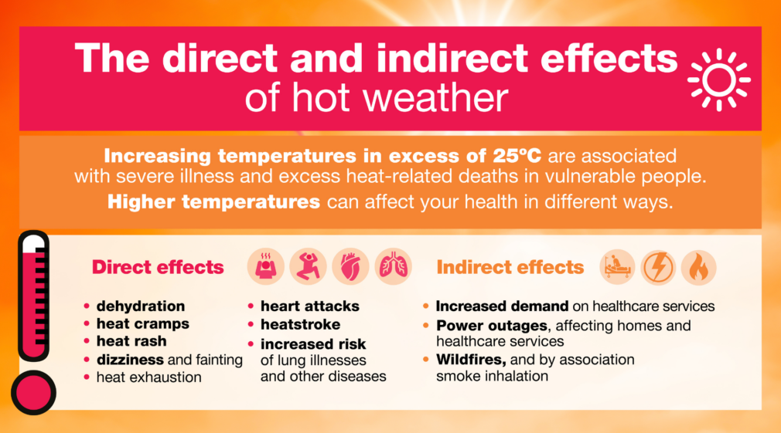
SALISBURY HOSPITAL WAITING LISTS

Salisbury Hospital are now required to validate their waiting lists every 12 weeks. In order to do that they will contact patients directly to confirm their place on the waiting list is still required.

They will contact you using their patient contact system DrDoctor, which will send either a text message (from number 07860 039092) or an email (from email no-reply@drdoctor.co.uk). The message will include a small number of simple questions for you to confirm your circumstances.

Please note that patients will remain on the waiting list unless they specifically request to be removed. A patient not responding will not result in a change of their position on the waiting list.

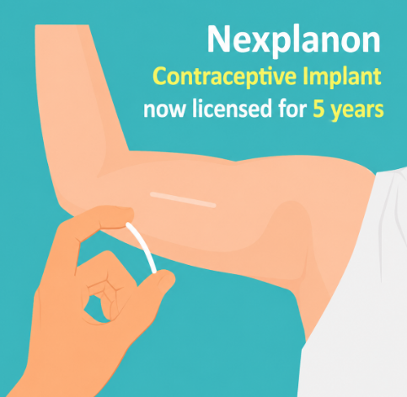
NEXPLANON CONTRACEPTIVE IMPLANT

The Nexplanon contraceptive implant is now licensed for 5 years of use, instead of the previous 3-year licence.

If you currently have a Nexplanon implant in place, it will continue to provide effective contraception for up to 5 years from the date it was inserted.
This means that many patients who were expecting to have their implant replaced at 3 years no longer need an appointment at this time.

DID YOU KNOW………………….

You can now self-refer yourself and your children to many different services.

This is the link to access this service;

Bath and North East Somerset, Swindon and Wiltshire Community Health or copy and paste https://referral.bswcommunityservices.co.uk/adults/form/wiltshire

- Advice and guidance to manage my health
- Carers and family support for health and social care needs
- Changes in my physical health that makes it harder to manage day-to-day tasks or that I'd like help with
- Changes to my bladder or bowel habits
- Eating and drinking
- Finding out if I might have attention-deficit hyperactive disorder (ADHD) or autism
- Help with sensory differences or processing needs
- Learning what I should or shouldn't eat for my health condition
- My breathing and respiratory health
- My diabetes
- My emotional wellbeing
- My foot health
- My hearing
- My heart health
- My independence and ability to manage my daily activities e.g. washing myself
- My joint pain such as hip and knee
- My memory or dementia
- My movement, coordination or falls and balance
- My palliative and end of life symptoms e.g. pain and nausea
- My weight
- New wounds and issues
- None of these options apply
- Social or financial needs
- Support and advice regarding medication for attention-deficit hyperactive disorder (ADHD)
- Support for my health needs as an autistic person (with or without a diagnosis) or person with a learning disability
- Support with talking and understanding words or my communication

Have you spotted our new TV in the waiting room?

Keep an eye on it for updates on all things health related and news about the surgery.

The benefits for using an App
- No need to type your medication onto the website form each time
- Just click the repeat medications you need on the App and submit
- Your request goes straight into the clinical system
- Quicker for the team to process your request
- Option to leave a textual message
Currently registered for online services?
- If you are currently registered for online services all you need to do is download your preferred App follow the instructions
- Login with your existing online services details
Not registered?
- Contact the surgery to obtain a password or complete the Register for Online Services form at meresurgery.co.uk
- Once this has been issued
- Download the App and start seeing the benefits
If you would like any further information, please do not hesitate to contact the surgery.

AIRMID AND NHS APP
Did you know by downloading the Airmid or NHS App, it will save you time when requesting medication.

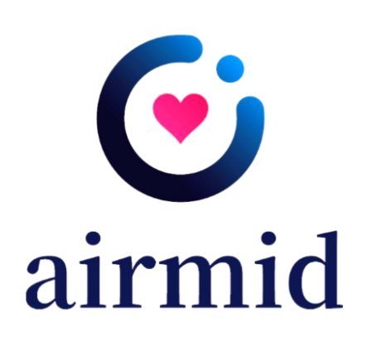
Please do not contact the surgery about this as invites will be sent out nearer the time for all eligible patients. It is important that all your contact details are up to date, so you receive these invites.

Keep an eye on our website and Facebook page for further information.

FLU AND COVID CLINICS

We will be planning our Flu and Covid vaccination clinics shortly and will endeavour to keep you updated with the dates as soon as they are confirmed.

